Project name: **Electronic Voting Machine using Raspberry Pi Board**.

**Electronic Voting Machine using Raspberry Pi Board**. :

We all are aware about the Electronic Voting Machine (EVM) which is used to vote in Elections, by pressing a simple button. so that only authenticated votes can be counted.

This Electronic Voting Machine using Raspberry Pi is simpler and easier, in comparison with other Voting Machine’s Projects.

**OBJECTIVE**

To automate the voting system without manual interface to detect which party has got highest votes and send the number of votes for the individual party into the could for the further reference .

**Required Components:**

* Raspberry Pi               - 1
* Push button                - 5
* Bread board                - 1
* Connecting wires
* 10K resistor               - 5
* LED’s                          - 5

**BLOCK DIAGRAM**

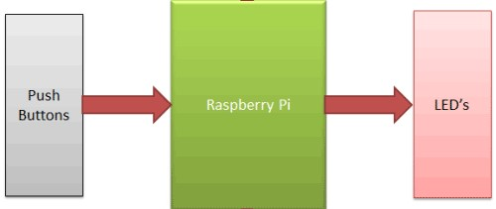

### How it Works:

In this project we have used four buttons to vote for four candidates or parties. We can increase the number of candidates, but for better understanding we have only used four here. When a voter presses any of the four buttons then the ‘voting count’ for the respected party or candidate, is increased by one each time. At the same time LED blinks and buzzer beeps for a second, to indicate that Vote has been given. After the Voting completes, we have a “Result” button, to show the results of the Voting. When we press this button, the result will be shown

**RASPBERRY PI:**

The **Raspberry Pi** is a series of small [single-board computers](https://en.wikipedia.org/wiki/Single-board_computer) developed in the [United Kingdom](https://en.wikipedia.org/wiki/United_Kingdom) by the [Raspberry Pi Foundation](https://en.wikipedia.org/wiki/Raspberry_Pi_Foundation) to promote teaching of basic [computer science](https://en.wikipedia.org/wiki/Computer_science) in schools and in [developing countries](https://en.wikipedia.org/wiki/Developing_countries). The original model became far more popular than anticipated, selling outside its [target market](https://en.wikipedia.org/wiki/Target_market) for uses such as [robotics](https://en.wikipedia.org/wiki/Robotics). It does not include peripherals (such as [keyboards](https://en.wikipedia.org/wiki/Keyboard_(computing)) and [mice](https://en.wikipedia.org/wiki/Mouse_(computing))) and [cases](https://en.wikipedia.org/wiki/Computer_case). However, some accessories have been included in several official and unofficial bundles

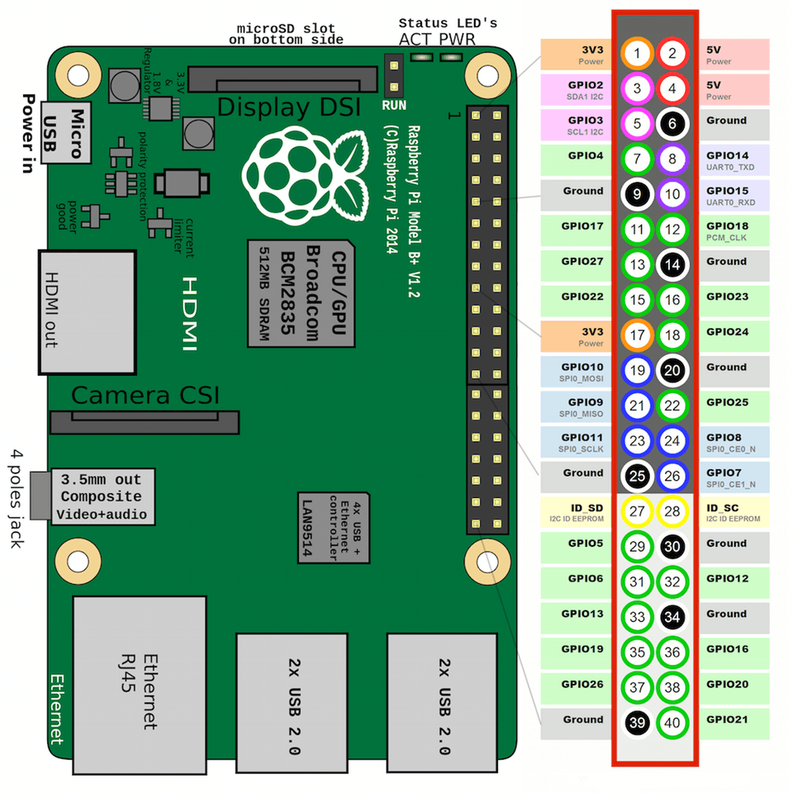

Program:

import http.client

import urllib

import RPi.GPIO as GPIO

import time

sleep = 60

key = 'QHHBG1DGHX64M6MM' # Thingspeak channel to update

GPIO.setmode(GPIO.BCM)

GPIO.setwarnings(False)

GPIO.setup(23,GPIO.IN,pull_up_down=GPIO.PUD_UP)

GPIO.setup(24,GPIO.OUT)

GPIO.setup(14,GPIO.IN,pull_up_down=GPIO.PUD_UP)

GPIO.setup(15,GPIO.OUT)

GPIO.setup(18,GPIO.IN,pull_up_down=GPIO.PUD_UP)

GPIO.setup(2,GPIO.OUT)

GPIO.setup(3,GPIO.IN,pull_up_down=GPIO.PUD_UP)

GPIO.setup(4,GPIO.OUT)

GPIO.setup(17,GPIO.IN,pull_up_down=GPIO.PUD_UP)

BJP=0

CNG=0

TDP=0

YSRCP=0

try:

while True:

button_state1=GPIO.input(23)

button_state2=GPIO.input(14)

button_state3=GPIO.input(18)

button_state4=GPIO.input(3)

button_state5=GPIO.input(17)

if button_state1==False:

BJP=BJP+1

GPIO.output(24,True)

print('your vote was registered for BJP')

time.sleep(0.2)

def thermometer():

while True:

#Calculate CPU temperature of Raspberry Pi in Degrees C

temp = 1

params = urllib.parse.urlencode({'field2': temp, 'key':key })

headers = {"Content-typZZe": "application/x-www-form-urlencoded","Accept": "text/plain"}

conn = http.client.HTTPConnection("api.thingspeak.com:80")

try:

conn.request("POST", "/update", params, headers)

response = conn.getresponse()

print ("x")

except:

print ("connection failed")

break

if __name__ == "__main__":

while True:

thermometer()

time.sleep(sleep)

break

elif button_state2==False:

CNG=CNG+1

GPIO.output(15,True)

print('your vote was registered for CNG')

time.sleep(0.2)

elif button_state3==False:

TDP=TDP+1

GPIO.output(2,True)

print('your vote was registered for TDP')

time.sleep(0.2)

elif button_state4==False:

YSRCP=YSRCP+1

GPIO.output(4,True)

print('your vote was registered for YSRCP')

time.sleep(0.2)

elif button_state5==False:

if (BJP>CNG):

if(BJP>TDP ):

if(BJP>YSRCP):

print('BJP WON',BJP)

time.sleep(0.2)

else:

print('ysrcp won',YSRCP)

time.sleep(0.2)

else:

if(TDP>YSRCP):

print('tdp won',TDP)

time.sleep(0.2)

else:

print('ysrcp won',YSRCP)

time.sleep(0.2)

else:

if(CNG>TDP):

if(CNG>YSRCP):

print('cng won',CNG)

time.sleep(0.2)

else:

print('ysrcp won',YSRCP)

time.sleep(0.2)

else:

if(TDP>YSRCP):

print('tdp won',TDP)

time.sleep(0.2)

else:

print('ysrcp won',YSRCP)

time.sleep(0.2)

else:

GPIO.output(24,False)

GPIO.output(15,False)

GPIO.output(2,False)

GPIO.output(4,False)

except:

GPIO.cleanup()

**CIRCUIT DIAGRAM:**

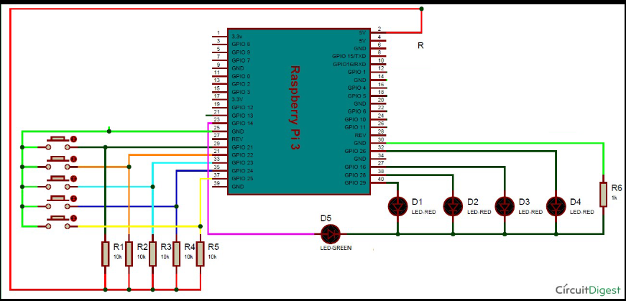

**Advantages :**

* Electronic voting machines are cost effective and economical. In the paper ballot, the amount of raw material used is higher. It directly impacts the environment as paper ballot uses papers to cast votes. However, the cost associated with holding elections with EVMs is considered to be negligible.
* The best thing about electronic voting machines is that they are real time savers. With electronic voting machines in place, one can count the votes in few minutes which makes life easier for the election officers on duty. In a paper ballot, the vote counting process is quite tedious and time-consuming.
* Electronic voting machines are designed in a way that they keep a track of number and details of votes recorded. The election commission can even save the data for a longer period of time which might be helpful for referencing in future.
* In a largely populous country where millions of people come out to cast their votes, the electronic voting machine works as a wonder. In a paper ballot, it takes a huge amount of time for everyone to cast votes.
* Few electronic voting machines also come with a voice support to assist the visually impaired voter. In such cases, the visually challenged person can cast their vote without any problem.

Disadventages:

* Although it takes the time to count votes that were captured using paper ballot but people fully trust the process as high technology are also vulnerable to hackers attack .
* The biggest change with technology is that no matter how much data it records but a single virus can destroy the entire data storage. The electronic voting machines which were used during the elections are susceptible to damage which will result in loss of data.
* Most of the electronic voting machines used in the country do not have any mechanism by which the voter can verify their identity before casting the vote due to which fake voters can cast numerous fake votes.
* Electronic voting machines can be tampered during its manufacturing and in such cases, it does not even require any hacker or malware to manipulate the actual voting.

